**2009-2016 Kickstarter Analysis**

**Conclusions:**

***Figure 1-A***

|  |  |  |  |
| --- | --- | --- | --- |
| **Count of state** | **state** |  |  |
| **Category** | **successful** | **failed** | **canceled** |
| film & video | 300 | 180 | 40 |
| food | 34 | 140 | 20 |
| games | 80 | 140 | 0 |
| journalism | 0 | 0 | 24 |
| music | 540 | 120 | 20 |
| photography | 103 | 117 | 0 |
| publishing | 80 | 127 | 30 |
| technology | 209 | 213 | 178 |
| theater | 839 | 493 | 37 |
| **Grand Total** | **2185** | **1530** | **349** |

**Overall, based on the count of Successful project states, as shown in *Figure 1-A*, Theater, Music and Film & Video categories are in the top 3. However, they also have most failure states compared to other categories. This could indicate that there is likely much more participation in these categories overall.**

***Note: The project state “Live” is only used in the current year and thus not comparable across the analysis timeframe. Project state “Live” will not be included in analysis comments.***

***Figure 1-B***

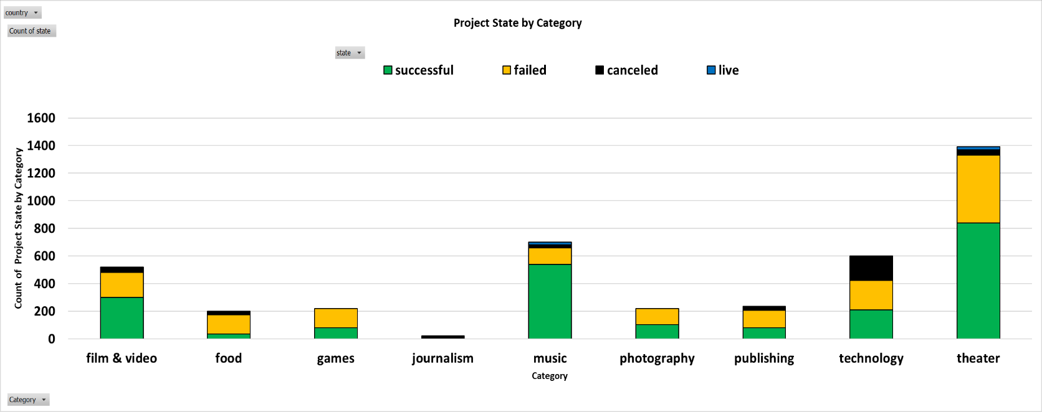

**Examining the aggregated results across all categories, as shown in *Figure 1-B*, confirms that Theater has far outpaced all other categories in number of records listed. It can also be seen that the Music category, which is 2nd in number of records, lags significantly compared to Theater at 2x its own record count.**

|  |  |  |  |  |  |
| --- | --- | --- | --- | --- | --- |
|  |  |  |  |  |  |

***Figure 2-A***

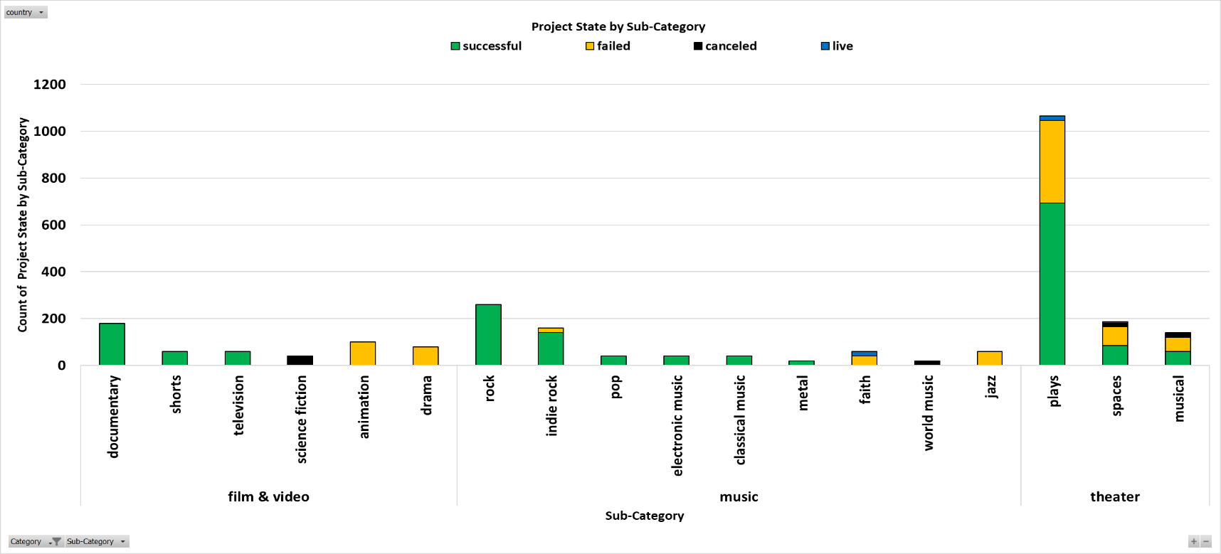

**At a more granular level, Plays, a sub-category of Theater, has a similar ratio of Successful to Failed project states when compared to other members of the same sub-category e.g. Spaces and Musicals.**

**However, as indicated in *Figure 2-A*, it’s clear that Plays is the dominant sub-category for Theater.**

***Figure 3-A***

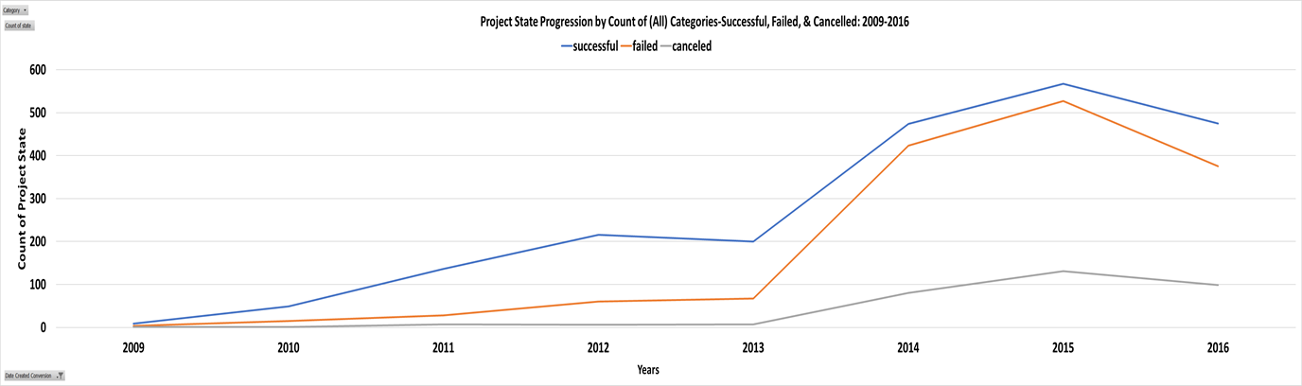

***Figure 3-A* shows increases from 2009 to 2012 for both Successful and Failed project states, but with a noticeable gap between the 2 states. In 2014 the sum of records for all project states more than doubled from the previous year. During this same period the gap between Successful and Failed project states began to converge, and Canceled project states began to rise. Movement towards convergence of Successful and Failed project states may be due, in part, to increased competition among projects for donations. However, in 2016 a decrease among all 3 project states can be observed.**

**Given that all 3 project states show a decrease in 2016; perhaps a more fundamental matter than category engagement is influencing the results.**

***Note: 2017 data does not appear to be complete and will not be included in analysis comments.***

***Figure 3-B***

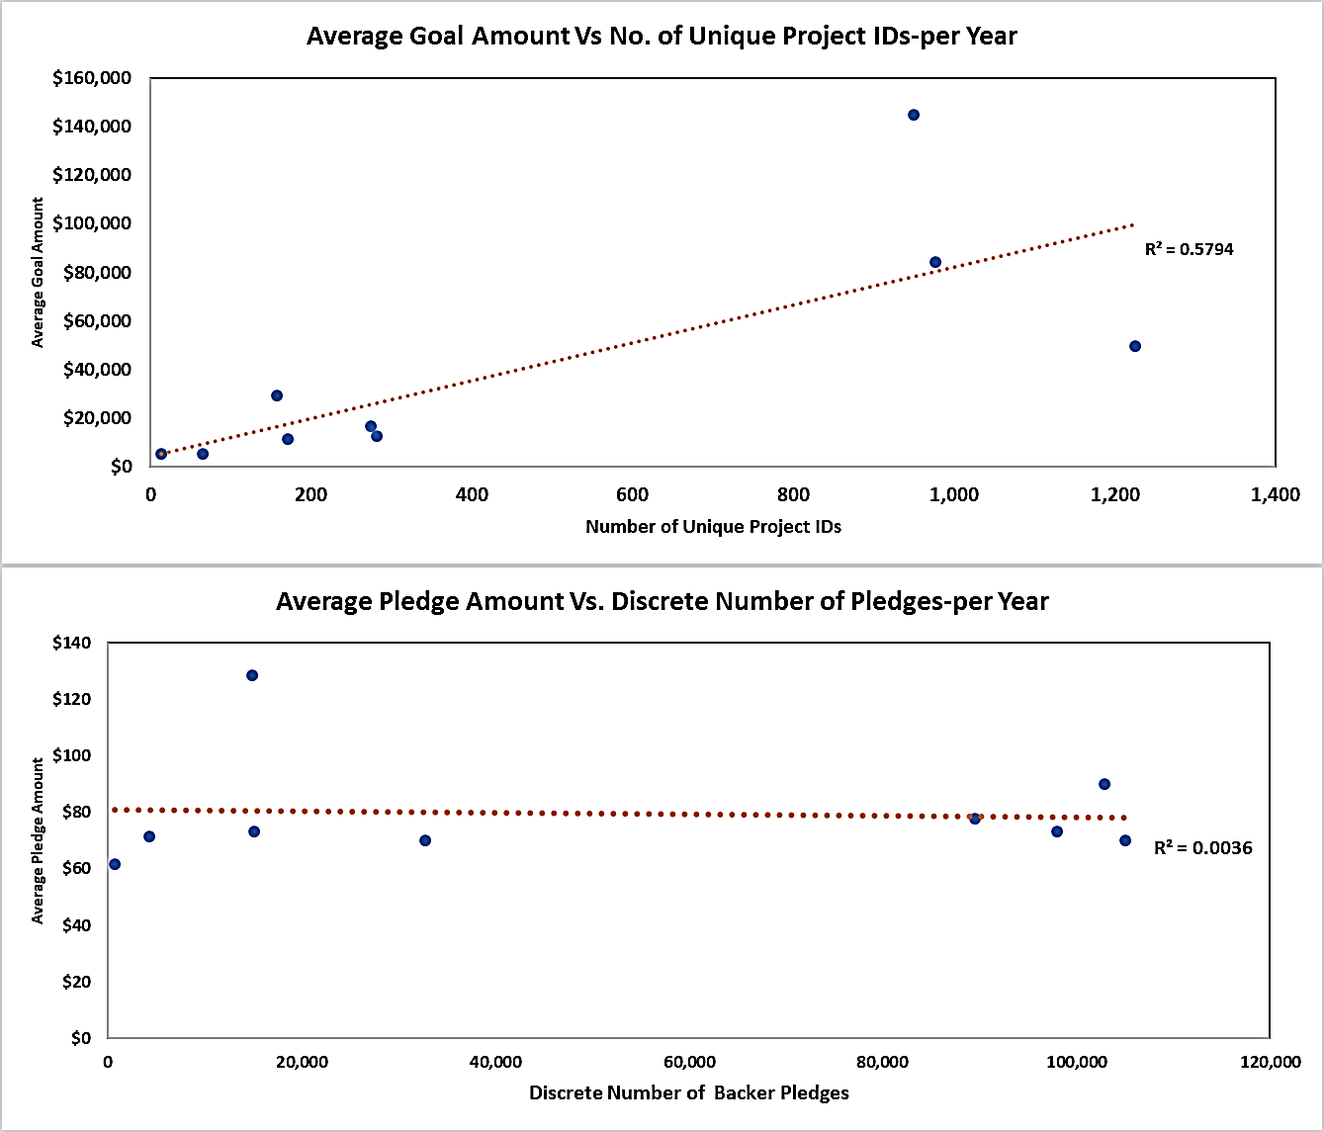





**The shift in trend during 2016, as seen in *Figure 3-A*, may be associated with an imbalance in marginal value generated by a new Kickstarter Project and a new Kickstarter Backer. *Figure 3-B* shows 2 scatter charts which illustrate the relationship between Average Goal/Pledge Amounts(Y-axis) and the Discrete Number of Backer Pledges/Number of Unique Project IDs(X-axis).**

**The uppermost chart shows a positive linear relationship between Average Goal Amounts and the Number of Unique Project IDs with a correlation strength of 57.9%. Simply put, for each additional project participating in Kickstater the value of the Average Goal Amount increases about $77.**

**Conversely, the bottommost chart shows no significant relationship exists between Average Pledge Amounts and the Discrete Number of Backer Pledges. Average Pledge Amounts do not respond in kind with additional Backer Pledges as Average Goal Amount responds to additional Project IDs. This suggests that Backer’s Pledge Amounts are constrained by more than the quantity of active pledgers each year.**

Figure 3-C

***Figure 3-C.1***

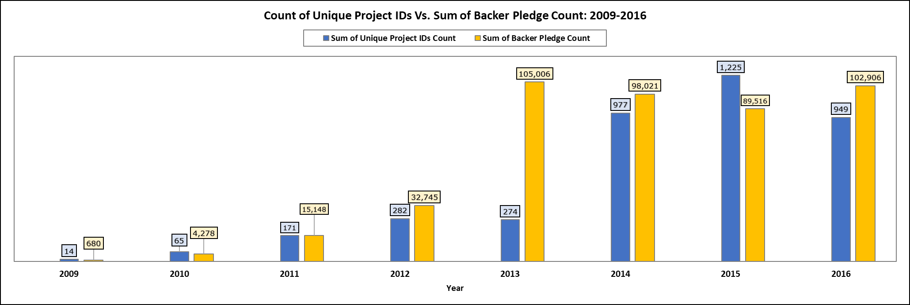

***Figure 3-C.2***

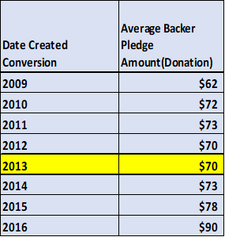

***Figures 3-C.1 and 3-C.2* show that in 2013 a large influx of Backer Pledge transactions occurred compared to open projects in Kickstarter. Despite this substantial increase of pledge transactions; the Average Backer Pledge Amount showed no relative change.**

**A sustained imbalance in marginal value of additional Backer Pledges to Active Projects in each year could lead to an increase in competition among projects given the tightening supply of pledge funds. A scenario like this was observed previously in *Figure 3-A* with rising levels of Failed project state records beginning in 2013.**

**However, a deeper analysis is needed to determine the number of Backer Pledge Transactions originating from a unique set of independent Backers, and number of Backers that pledged multiple times.**

**Limitations/Suggestions:**

# 

***Demographic Information***- Data on both the project owner and pledger would allow for a deeper analysis of common or opposing attributes that may affect behavior. Data points such as age, gender, education, nationality would be quite helpful. Particularly with a focus on income levels of Backers as “wallet size” is an important factor to consider.

***Variable Refinement***- Analysis on discrete data points, such as “Count”, out any context can limit the ability to answer more nuanced questions.

For example, it may advantageous to divide the count of project state in a category by the grand total of all records in the same category.

This can give an idea of “Throughput” for each state, and essentially convey each state per given opportunity. This helps control for major swings in the data and helps to spot trends more efficiently.

***Descriptive Statistics***- Performing a descriptive stat analysis on key data points can give better direction understanding during an exploratory analysis. A Box & Whisker plot and Histogram can give good indications of outlier behavior and central tendency.